1. System Architecture Diagram:

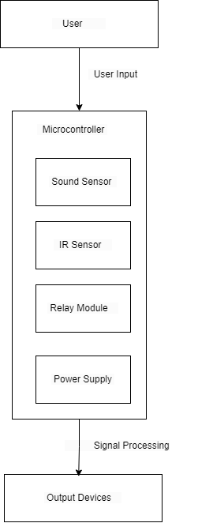

1. Use case Diagram:



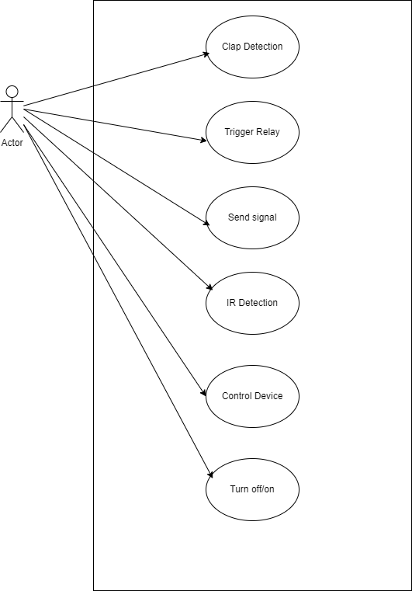

C] Sequence Diagram:

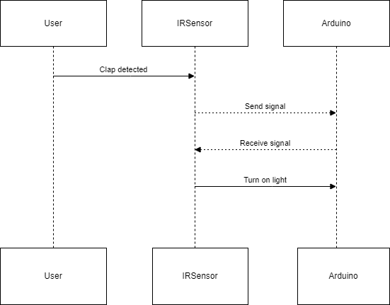

D] DFD Diagram:

Level 0:

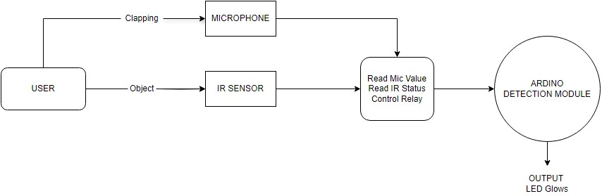

Level 1:

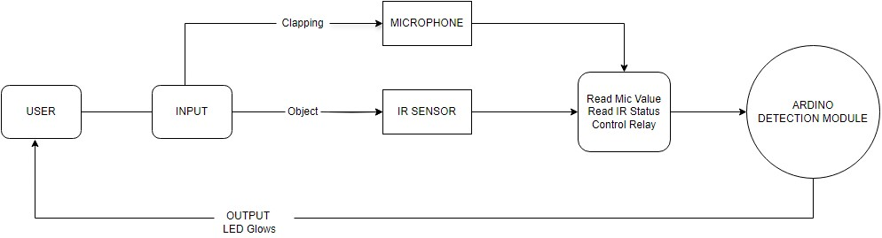

E] Component Diagram:

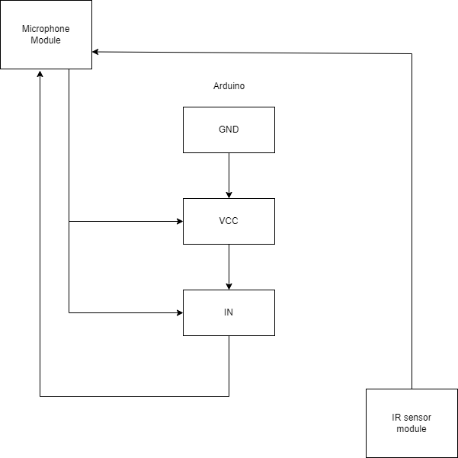

F] State Machine Diagram:

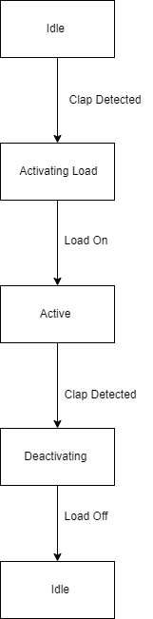

G] Activity Diagram

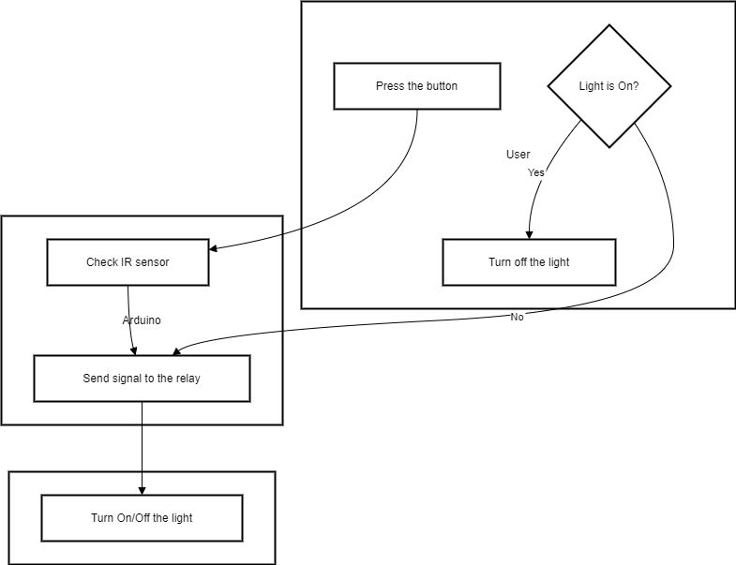

H] Deployment Diagram:

